

RT- Site Arrival
Cheney Manor – Beta Plant

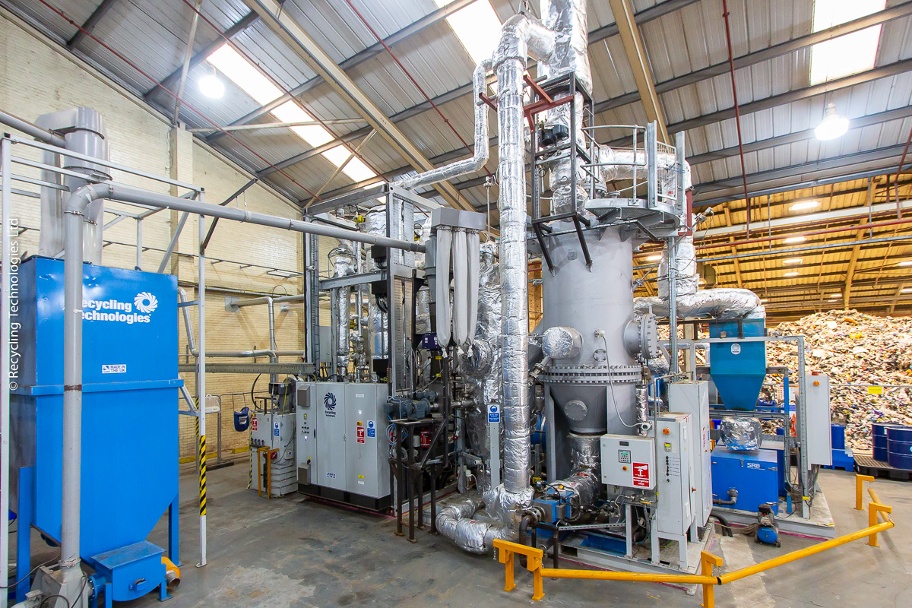
Contents
RT- Site Arrival 1
Arriving at the Beta Plant 3
Beta Plant Site 4
Emergency Procedure 5
Evacuating 5
Visitor’s Declaration 6
VISITOR’S DECLARATION (VISITOR’S COPY) 6

Arriving at the Beta Plant
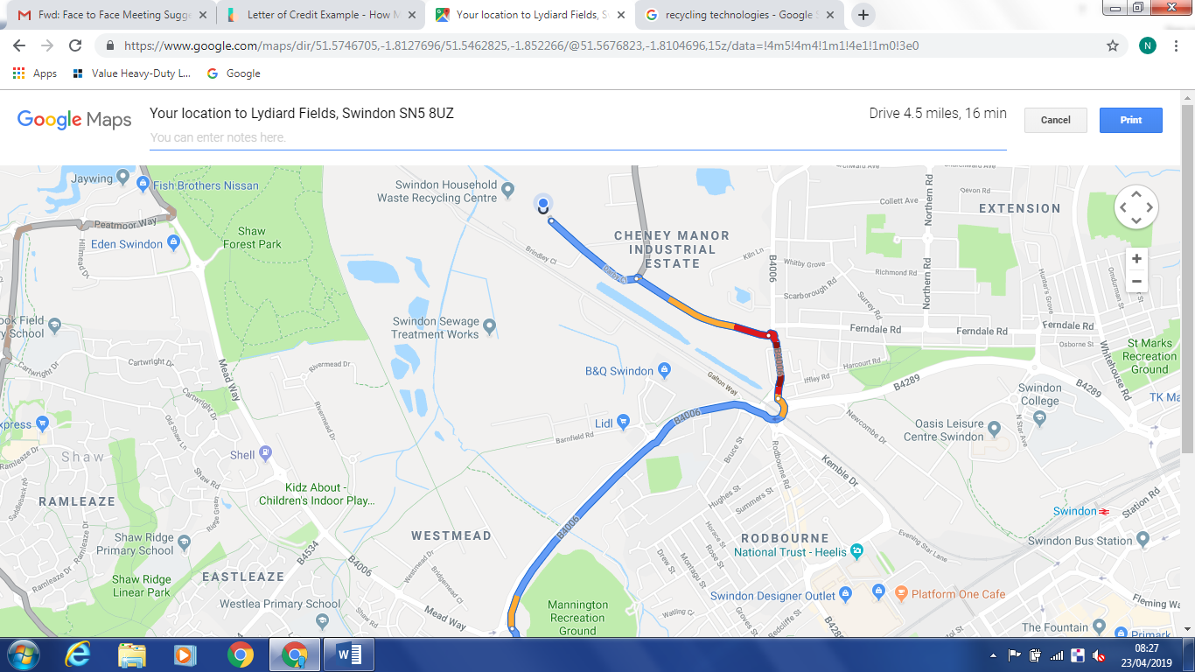

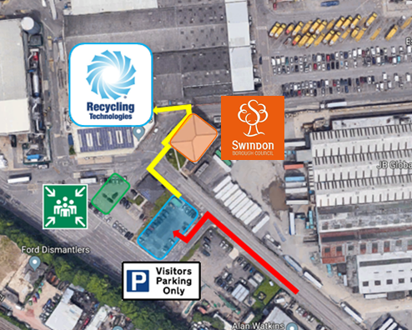
Recycling Technologies
Swindon Borough Council
Waterside Park
Darby Close
Cheney Manor Ind Est.
Swindon
SN2 2PN
- The visitor’s car park is located on the left just before entering the waste disposal site
- Keep to the path and cross at the crosswalks
- Upon arrival head to Swindon Borough Council’s reception, let them know you are here for Recycling Technologies and collect a high-visibility vest
- If no one is available at the reception you can contact our offices on 01793 8279565
- The muster point is highlighted in green on the map, which is used in case of an evacuation.

Beta Plant Site
Once on Recycling Technologies’ Beta Plant site there are health and safety rules to abide by and hazards to be aware of.
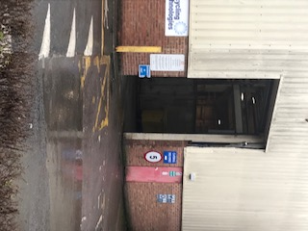
A high-visibility vest or jacket is required at all times while on Swindon Borough Council’s waste disposal site and while at the Beta Plant.
When walking from the visitor’s carpark to the Beta Plant, keep to the walkways and crossings and when entering the warehouse use the pedestrian access door.
Upon arrival a Non-Disclosure Agreement will need to be signed or the one provided with this arrival pack will need to be signed and presented to your host.
Visitors will need to be escorted around the Beta Plant at all times while staying on the yellow marked pedestrian walkway. If for any reason while during your visit you will need to leave the yellow walkway, have your host contact the plant’s manager to obtain the correct Personal Protective Equipment.
Hazards to be aware of while on site include but are not limited to:
- Disease
- Fire
- Vehicles and work transport
- Slips, Trip & Falls
It is recommended that after your visit or before eating to thoroughly wash your hands. Hand sanitiser can be found at the Beta Plant site also.

Emergency Procedure
In the unlikely event an alarm is raised please stay with your host and make your way to the muster point.

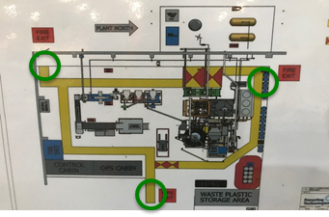
Evacuating
To evacuate the plant in the case of an emergency there are three fire exits.
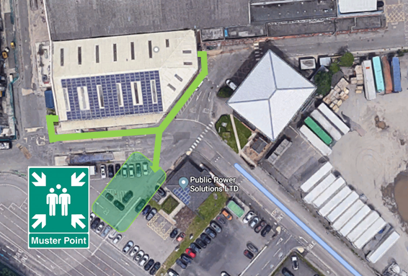
Once out of the plant make your way to outside the building and head towards the muster point adjacent to the visitor car park.

Visitor’s Declaration

I, the undersigned, understand that I am visiting a secure facility operated by Recycling Technologies Limited located at Cheney Manor, Darby Close, Swindon, Wiltshire, SN2 2PN.
I agree to abide by Health and Safety regulations relating to this facility.
I acknowledge and agree that all property, materials, technology, knowledge and information at this facility belongs to Recycling Technologies Limited.
I also acknowledge and agree that unless otherwise authorised in writing I will not steal, copy, reproduce or disclose to anyone else any property, materials, technology, knowledge or information that comes into my possession during my visit to Recycling Technologies Limited’s facility.
I understand and agree that I cannot discuss my visit to Recycling Technologies Limited’s facility with other employees or agents of the company that I represent unless that employee or agent has signed a visitor’s declaration or if the company that I represent has signed a relevant confidentiality agreement. In addition, I agree that will not take any photographs or recordings inside or directly outside of the facility.

SIGNED: ……………………………………………………………………………….…
NAME: …………………………………………………………………….……………
COMPANY: ………………………………………………………………………………….
DATE: ………………………………………………………………………………….

Visitor’s Declaration (visitor’s copy)

I, the undersigned, understand that I am visiting a secure facility operated by Recycling Technologies Limited located at The Swindon Household Waste Recycling Centre, Swindon, Wiltshire, SN2 2PN.
I agree to abide by Health and Safety regulations relating to this facility.
I acknowledge and agree that all property, materials, technology, knowledge and information at this facility belongs to Recycling Technologies Limited.
I also acknowledge and agree that unless otherwise authorised in writing I will not steal, copy, reproduce or disclose to anyone else any property, materials, technology, knowledge or information that comes into my possession during my visit to Recycling Technologies Limited’s facility.
I understand and agree that I cannot discuss my visit to Recycling Technologies Limited’s facility with other employees or agents of the company that I represent unless that employee or agent has signed a visitor’s declaration or if the company that I represent has signed a relevant confidentiality agreement. In addition, I agree that will not take any photographs or recordings inside or directly outside of the facility.

