CIWM Trustee (General Councillor)
CIWM Trustee Board (General Council)
Role description
What team do I work in?
CIWM General Council/Trustee Board
CIWM's Trustees are at the peak of CIWM's governance structure. The purpose of the role of Trustee is to ensure CIWM pursues its stated objectives. The Board of Trustees includes the CIWM Presidential Team.
Am I a budget holder?
Trustees are responsible for challenging the budget set by the CIWM team and approving the CIWM annual budget against strategy.
Who are my key stakeholders/key relationships with both internally and externally?
Trustees are representatives of CIWM and engage with a variety of stakeholders including the media, CIWM Members, CIWM staff, volunteers and other industry bodies and organisations in the sector.
What is the purpose of my role?
The duties of a Trustee are:
- To ensure the organisation pursues it’s stated objects, as defined in its governing document, by developing and agreeing a long-term strategy.
- To ensure that the organisation complies with its governing document, charity law, company law and any other relevant legislation or regulations.
- To ensure that the organisation applies its resources exclusively in pursuance of its charitable objects for the benefit of the public.
- To ensure the organisation defines its goals and evaluates performance against agreed targets.
- To ensure the financial stability of the organisation.
- To safeguard the good name and values of the organisation.
- To protect and manage the property of the charity and to ensure the proper investment of the charity’s funds.
- To ensure the effective and efficient administration of the organisation including having appropriate policies and procedures in place.
- To follow proper and formal arrangements for the appointment, supervision, support, appraisal and remuneration of the Chief Executive.
In addition to the above statutory duties, each Trustee should use the specific skills, knowledge or experience they have to help the board of Trustees to reach sound decisions. This may involve scrutinising board papers, leading discussions, focussing on key issues, providing advice and guidance on new initiatives, or other issues which the trustee has special expertise.
As part of the leadership team Trustees are responsible for ensuring CIWM provide a stimulating and supportive environment where all views, ideas and suggestions are of equal value and the team are empowered to ‘have a go’.
Trustees should ensure individual differences are respected and look to support everyone to succeed by providing the right resources, environment and timely feedback so people can flourish.
What skills or competencies are required to perform this role?
Each year as part of the annual review the CIWM Trustee Board are assessed against the agreed skills matrix. This matrix includes the following skills which are seen as essential for leading CIWM. We actively seek Trustees from a diverse range of backgrounds to ensure that together they can provide knowledge and skills in the following areas -
- Membership - Good knowledge of membership organisations, ideally at Board level
- Financial Management - Qualified accountant or significant equivalent experience, ideally at Board level
- Commercial/Marketing/ income generation - Successfully operating in a commercial business at Board level, significant experience of a sales or marketing based operation comparable to CIWM
- (Charity) Governance & Charity Law - Expertise in charity governance or other corporate governance
- Sector knowledge - Significant experience of the resource & waste management sector in private, public or third sector
- Strategy - Experience in formulating and overseeing strategy
- Policy/Government - Experience of working with/in Government (with/in any of the five national administrations or equivalents)
- Education/Qualifications - Knowledge of the education world including regulated qualifications
- Digital/Technology - In touch with digital developments, technology for customer service, engagement, etc, ideally with experience of applying it to a membership or subscription context
- Geography - Significant experience of operating in Northern Ireland, Republic of Ireland, Scotland or Wales in a relevant context. This would normally be alongside one of the other elements and must not be misinterpreted as a ‘representative’ of one or more of those countries.
- HR - HR Employment law and practice, training and professional development, equal opportunities and diversity
- Marketing and Communications - Strategic marketing and communications experience. Development of brand strategy
CIWM Trustees must be CIWM Members but do not need to have reached a specific grade. The CIWM constitution, our governing document, requires that the majority of Trustees at any time must be CIWM Chartered Members or Fellows. If we are specifically looking for Members at Chartered or Fellow grade this will be specified on the call out to Members which is usually sent in Spring each year.
Time commitment
The CIWM Trustee Board meets at least four times a year for around 3 hours per meeting. They occasionally have additional meetings to cover particular topics and to join meetings of other committees. In addition, CIWM Trustees select members of the Trustee Board to take on roles on other committees such as the Corporate Governance and Professional Ethics Committee.
Each year Trustees also set up working groups to cover particular projects, for example the EDI working group, and these usually have a meeting a month for a shorter amount of time, for example six months, to undertake a specific piece of work.
Trustees are required to read board papers and other reports to ensure they are fully prepared for meetings. We also ask our Trustees to maintain their knowledge of their role as a Trustee which may require attending additional training or reading guidance from the NCVO or the charities commission.
As representatives of CIWM, Trustees are also interviewed for CIWM’s Circular magazine, speak on podcasts and webinars, attend centre meetings and occasionally speak publicly on CIWM’s behalf.
How do CIWM staff and volunteers conduct themselves?
All CIWM staff and volunteers are expected to conduct themselves in a professional manner with all colleagues, external stakeholders and members. As a Trustee you will be required to uphold the values of CIWM known as the CIWM Way.

CIWM Way
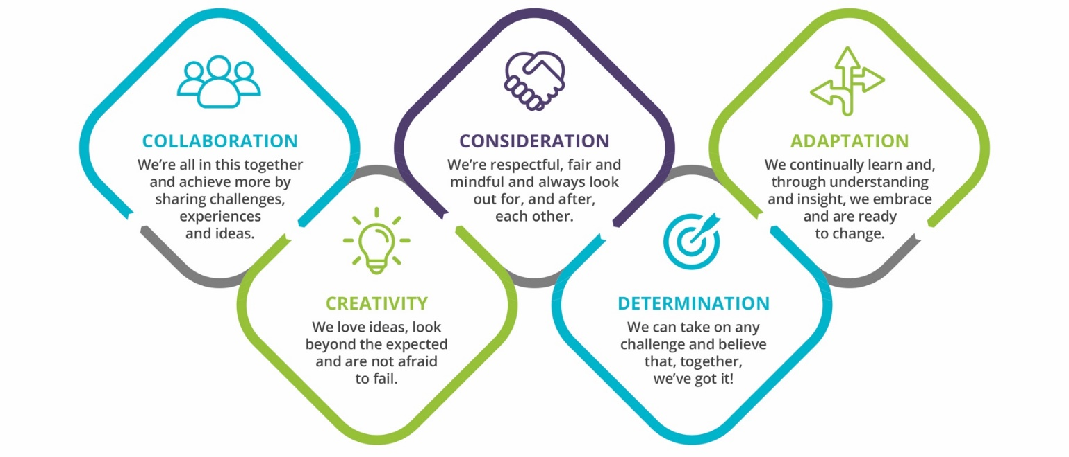
Our shared attitudes and behaviours

What we expect from each other
We will:
- Support and trust each other, be approachable, keep an open mind to new ideas, listen, respect and value the views of others.
- Always aim to have a positive mindset and, where challenge is needed, we will do so respectfully and constructively.
- Be mindful and considerate of the pressures and deadlines we all face, offering support and checking in with each other.
- Have the belief that we can succeed by being solutions-focussed, and persevere even when the going gets tough.
- Look forward, not back, embrace feedback, act with honesty and integrity in everything we do and have fun!
We won’t:
- Be judgemental or confrontational, or ignore others’ views and ideas, even if they don’t match our own.
- ‘It’s not my job’ or ‘we’ve always done it this way’ are not in our vocabulary.
- Siloed working, negativity and blame have no place at CIWM.

Watch our CIWM Way video here - https://vimeo.com/554186165/3e1315accc

